Weathering, Erosion, and Deposition: Big Bend Regions (Trans Pecos/Chihuahuan Desert)
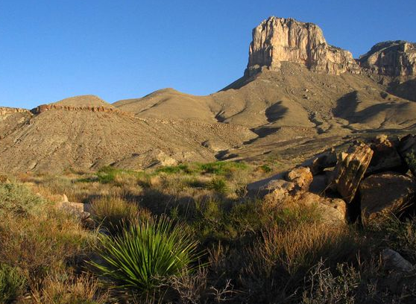
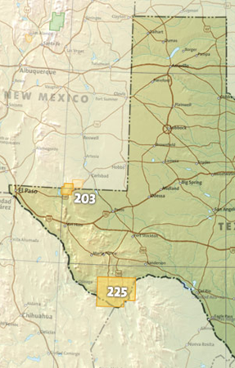
Big Bend National Park-Chisos Mountains (granite) and deserts

Guadalupe Mountains National Park- Limestone Mountains
The Trans Pecos ecoregion includes the Chihuahuan Desert. The Guadalupe Mountains and the Davis Mountains are located in this ecoregion, making it the most mountainous area of Texas. In general, soil in this region is eroded due to the decline of grasslands. Big Bend National Park is also located in this ecoregion. Flash-flooding and rapid runoff are agents of erosion in the park. Erosion of the limestone cliffs takes place because of acid rain.
Weathering, Erosion, and Deposition: The Piney Woods
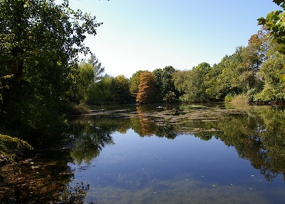
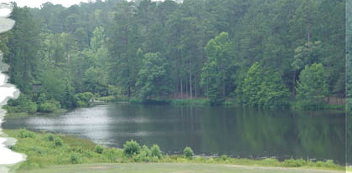
The Piney Woods ecoregion receives ample precipitation and has abundant vegetation. Vegetation such as pine forests and grasses holds soil in place. Very little erosion takes place in these areas. Seasonal flooding occurs along riverbanks. Sediments are carried and deposited in different locations along the river route. The thick areas of vegetation help to inhibit river erosion. These characteristics of the Piney Woods ecoregion provide stable environments for wildlife to thrive. However, the soil of this region is predominantly coarse textured sands, produced from weathered granite over thousands of years.

Weathering, Erosion, and Deposition: Gulf Coast (Plains and Marshes)
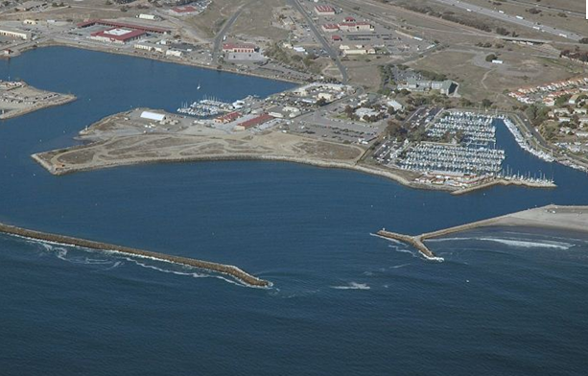
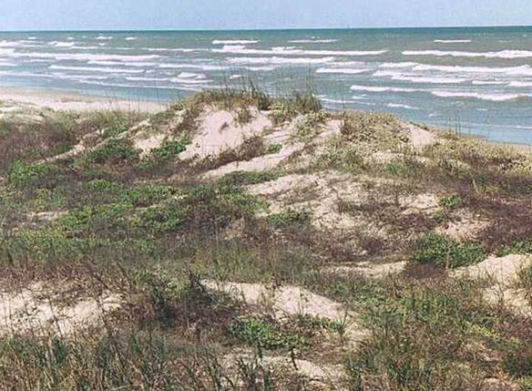

The Gulf Coast Plains and Marshes experience large amounts of weathering, erosion, and deposition. Wave action, a cause or agent of weathering, erosion, and deposition, is constant along the Texas coastline. The effects of wave action may happen slowly or very quickly. Sediments may be weathered and eroded along beaches and carried out into the ocean to form sand bars. Sediments may also be deposited along the coast, forming sand dunes and/or barrier islands over time. During catastrophic events such as hurricanes, wave erosion accelerates. Environments for wildlife such as shorebirds and turtles can be destroyed quickly.
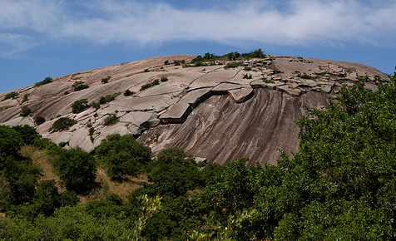
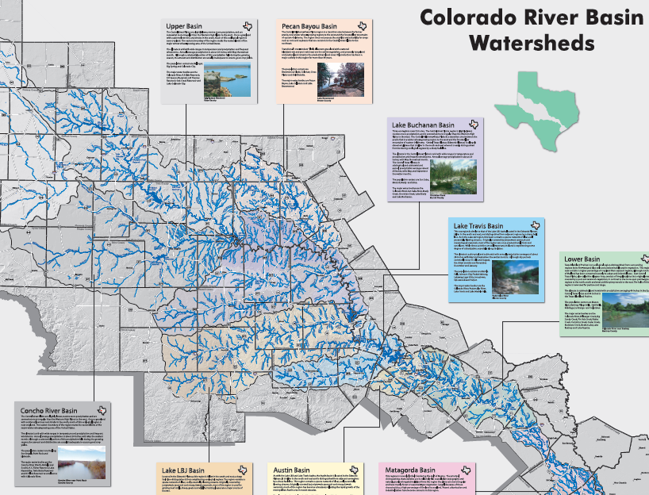
Weathering, Erosion, and Deposition: Hill Country (Edwards Plateau/Llano Uplift)

The Edwards Plateau/Llano Uplift ecoregion is located in central Texas. An unusual landform in this ecoregion is a dome of granite called Enchanted Rock. The Enchanted Rock experiences a type of physical weathering called exfoliation. Exfoliation is a process in which the surface of rock weathers by peeling into sheets instead of breaking down into small sediments. This region is often referred to as Central Texas or The Hill Country. This area is considered the highest risk area in the country for flash floods. Weathered soil and rock from the ecoregion is eroded and deposited in the upper South Texas Plains Ecoregion.
Weathering, Erosion, and Deposition: Panhandle Planes (High Plains)
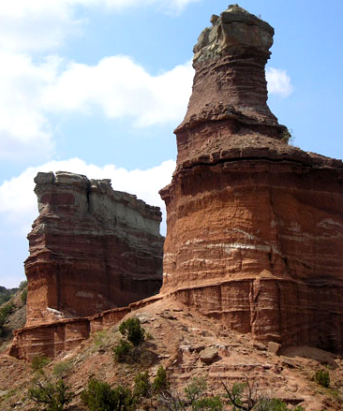
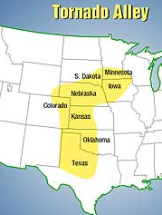
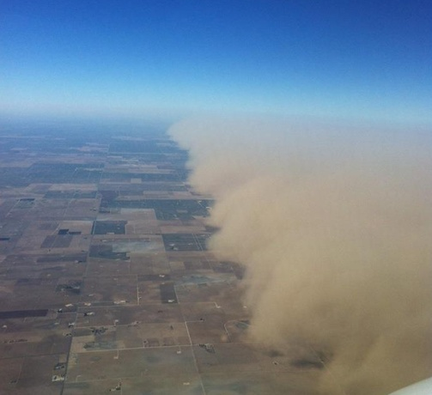

The Texas High Plains span from Southern West Texas into the Panhandle. This semi-dry area is predominantly flat with deposits of wind-blown materials that blanket the region. Wind is a primary agent of weathering and erosion in this region. Large dust storms are common in this ecoregion. The dust storms carry soil and deposit it in new areas in the ecoregion. Tornadoes are a CATASTROPHIC EVENT that is common in this ecoregion. Tornadoes can cause weathering of land features, erosion of soil, and deposition of soil and debris. Areas such as Palo Duro Canyon, are formed by weathering and erosion caused by wind and water action.
Weathering, Erosion, and Deposition: South Texas Plains
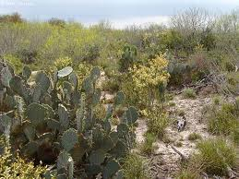.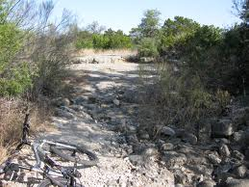
The South Texas Plains is largely covered with materials carried out from the erosion of the Edwards Plateau. The area adjacent to the Balcones Escarpment, is characterized by black soils that extend from Austin to San Antonio and westward. The area closer to the coastal comprises the low, flat country just interior from the coast. Further south, the area is blanketed with a thick cover of sand, some of which occurs as dunes. Most of the sand area, however, is stabilized by vegetation. Still farther south is the lower Rio Grande country, consisting of a smooth wavy to slightly rolling upland of black-earth soils and the lowland of the Rio Grande, including its delta area.

Weathering, Erosion, and Deposition: Prairies and Lakes (Post Oak Savannah)
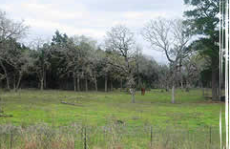
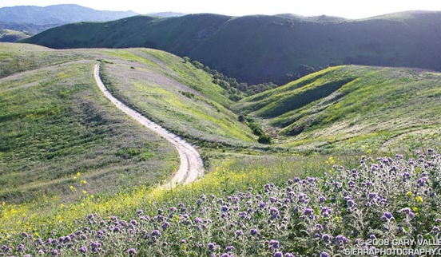

The Prairies and Lakes ecoregion is an area of north central Texas with gently rolling hills and lightly wooded plain. This area generally receives a moderate amount of rainfall that helps shape the land. Trees and grasses prevent large amounts of soil erosion due to water and wind.

Weathering, Erosion and Deposition: Prairies and Lakes (Cross Timbers and Prairies)
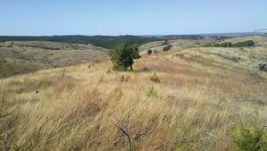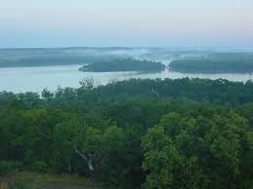
The landscape is categorized by irregular plains with acidic soils along the parallel ridges and valleys, sandy and sandy loam soils on the uplands, and clay and clay loams occupy the low-lying areas. Elevation increases gradually from southeast to northwest. Additionally, many areas in this ecoregion are underlain with clay pan which affects water movement and availability for plant growth. The overall annual precipitation in this ecoregion is approximately 102 centimeters.

